

User Manual

It is **HIGHLY RECOMMENDED** to read this manual prior to use of exebeatz application!!

**Getting Started ………………………………………………………………… 2**

System requirements…………………………………………………………………

Installation guide …………………………………………………………………

Workout recommendations ………………………………………………………………....

**User Interface …………………………………………………………………**

First Time Login …………………………………………………………………

Creating Account …………………………………………………………………

Workout Selection …………………………………………………………………

Single Workout …………………………………………………………………

Full Body Workout …………………………………………………………………

Credits …………………………………………………………………



**Getting Started**

* **System Requirements**

1. Application is compatible to devices with the following characteristics.
   1. iOS.
   2. Windows 7-10
   3. Linux
   4. A laptop (recommended for mobility) or desktop with a monitor, keyboard and speakers.
   5. IDE (Net Beans IntelliJ, Eclipse, etc…)

* **Installation Guide**
  1. **Java installation.**

1. Download and install the latest version of Java from Oracle.
2. Run and extract the components of the Java Jar file.
3. Install suitable IDE (Net Beans, Eclipse, IntelliJ etc..).
4. Proceed to Github and download the project package folder.
5. Create new project in Preferred IDE and import the project package folder.
6. Proceed to database installation instruction below.
   1. **Database installation**
      * 1. Proceed to GitHub and follow the link to the MySQL site.
        2. Download the appropriate version of MySQL server and server manager, Workbench.
        3. Unzip and install the archived folder.
        4. Open up command prompt or in mac OS System Services and run the server which requires the systems administrators password.
        5. Run the MySQL workbench and input the auto-generated password to begin using the server.

* **Workout Preparations**
  1. Make sure to have plenty of space.
  2. Have plenty hydration available.
  3. Eat for fuel, but do not eat large meals prior to workout.

**User Interface**

* **First Time Login**
  1. Upon the first time opening the application, you will need to create an account.

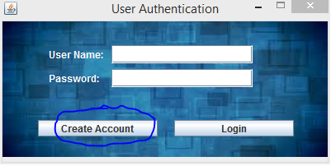

* 1. 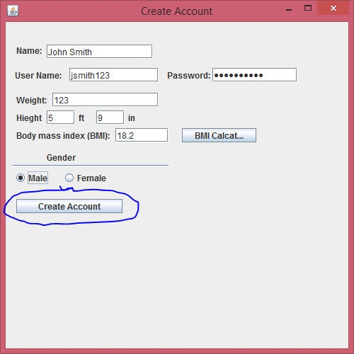Enter all information requested in the Account creation window, then click create account.
  2. A window will pop up confirming account creation.

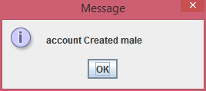

* **Workout Selection**
  1. At the workout selection dashboard, you are able to select between a sectional or a full body workout.

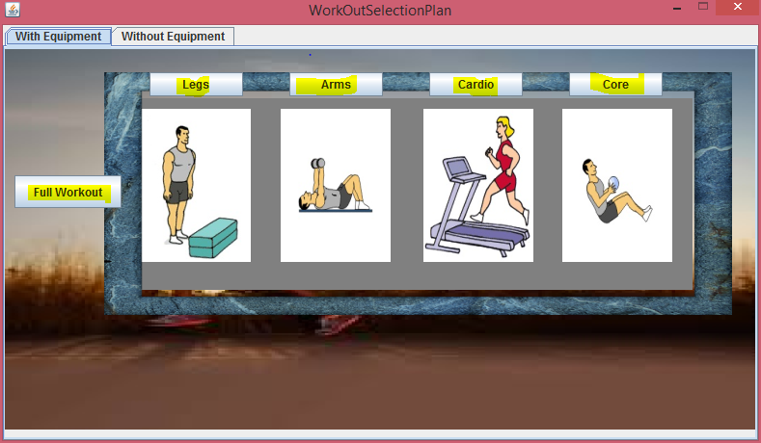

* 1. Different exercise options are available for those who chose to exercise with/without equipment.

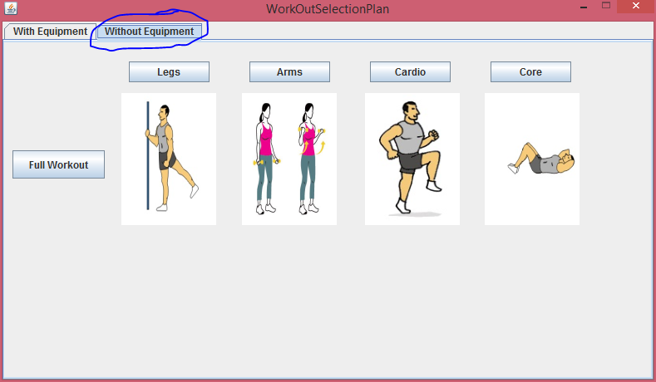

* **Single Workout**
  1. Upon Selection of body part (Arms, Legs etc.), the application will assume full sectional workout of the selected target areas.
  2. To do a single exercise, select the back button after completion of an exercise.

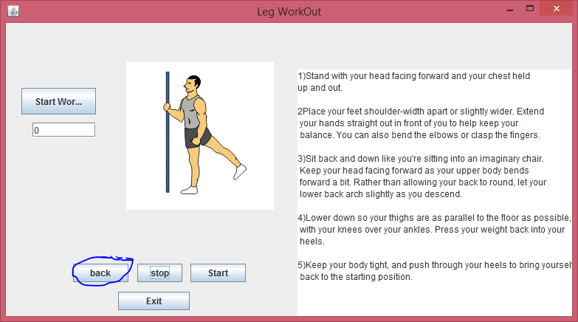

* 1. Once you select the exercise, an animation of the exercise with instructions will appear.
     1. Here you are able to enter how long you want to exercise.
     2. When the timer hits zero the application will move on to the next exercise in the section.

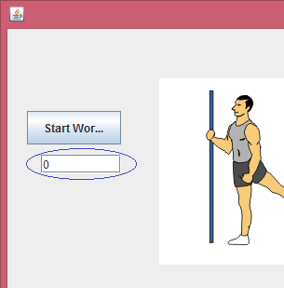

* **Full Body Workout**
  1. If you want to select a Full Body Workout, select the **Full Workout** button at the Dashboard.

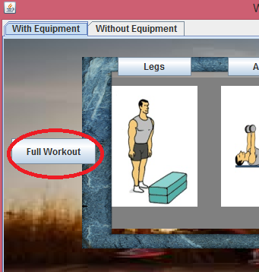

* 1. The Application will then proceed through each exercise in order of the Cardio, Core, Arms then Legs.
  2. Tip: You are still able to select how long you want to do each exercise.
  3. Once completed you will be taken back to the dashboard.

**Credits**

**Alea Cobham** *Assistant Chief Developer*

**Kenneth Okoye** *Backend Developer*

**Michael Acheampong** *Developer*

**Natsai Ndebele** *Developer/Software Architect(designer)*

**Amanuel Larebo** *Chief Developer*

**Marcus Williams** *Documenter(User Manual and Deployment Document)/Tester*